Date – 31 july, 2026
Todays topic – types of object
Object is table in salesforce.
Two types –
- Setup objects
- Non setup objects
Setup objects- objs which are used to do system settings only.
Cant create record/data.
Only standard.
Example- user interface, company information
Non setup objects- objs are used to store (data)records in it.
Standard and custom both.
Example- account, contact, applicant.

Objects Description
- Account - it is used to store company related info.
- Contact – it is used to store employee related info
- Opputunity – it is used to store finance or money related info
- Lead – assignment
- Case – used to store customer cases.

- Selects apps from quick search – “aps”
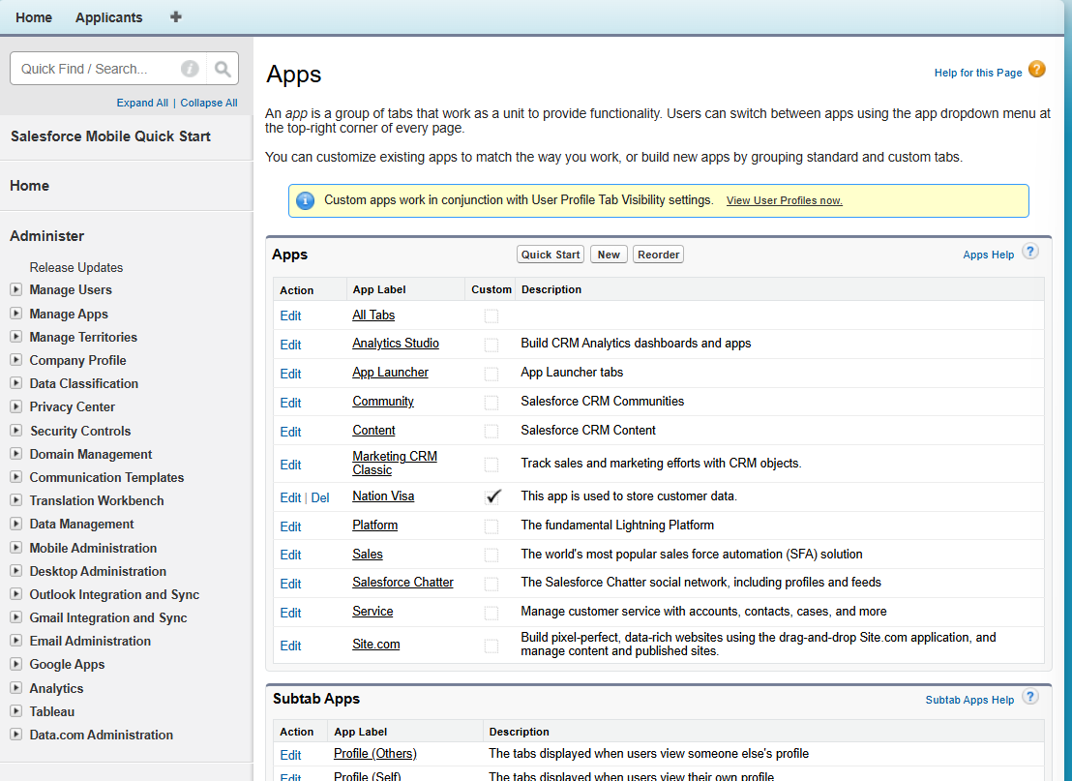

- Click on nation visa-
Edit it and add these-
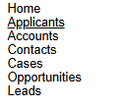
- Choose nation visa-
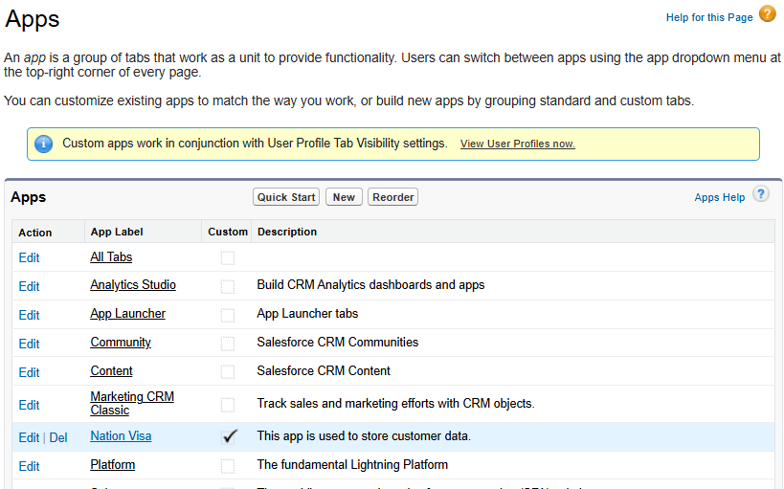

- Click on edit-
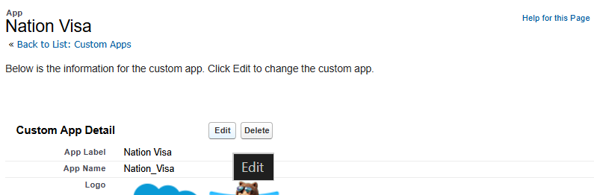
- Add all other from here-
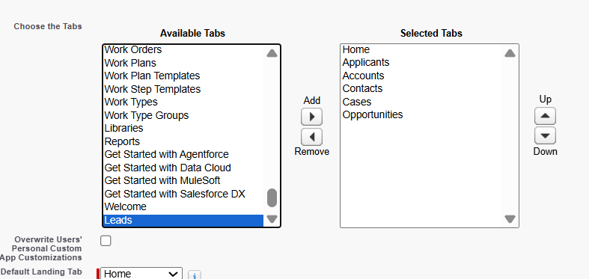
- Savce it-
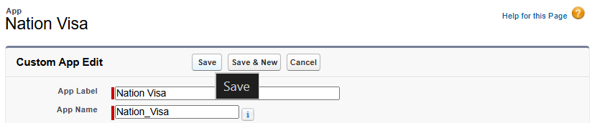

- Result –
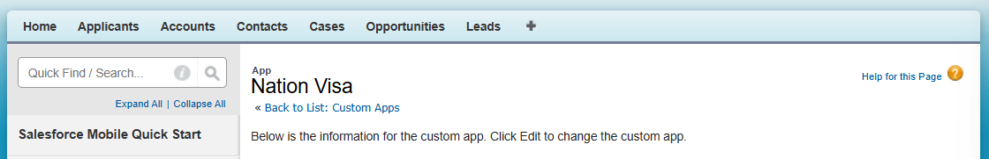

ACCOUNTS
Click on accounts - > new.
